Java Debugging assignment

When I briefly look at the program, I think the program acts as a calculator of the stock market on gold, silver. Then it asked the user to enter the day of the week and amount they bought, at the end it calculated the total amount and printed the receipt.

Categories of error:
- Syntax:
. Line 6 ( Scanner sc = new Scanner(System.in) ) forgot ;

- Logic error:
. at line 6 we use Scanner object, the problem is we never close the scanner object. The fix is to add sc.close(); at the end of the program.

- Incorrect condition
. Line 24 inside the for statement, i <= numItems isn’t a correct logic, because if user selects 2 items the code will run from index 0,1,2 total of 3 items instead. The fix is to change from i <= numItems to i < numItems

- Unsuitable type
. Line 43 inside if statement discountRate = 0.2 but discountRate itself isn’t double data type, it’s an int data type. The fix is to change its data type from int to double at line 12

- String comparison
. At line 43 and 45 the if statement compares to “Gold” and “Silver” if the user types in “gold” or “silver” the discount won’t be applied. The fix is to compare to lower case “gold” and “silver” then we must convert the user’s input to all lowercase by adding
membership = membership.toLowerCase(); on top of it.
. At line 43 and 45 it uses the compare method “==” it works but is not ideal. The fix is to change and use membership.equals(“gold”) instead as it’s ideal and safer.

- Loop
. Line 25 inside the for statement, our print statement doesn’t print the correct number of items. If user select 2 item they would expect item 1 and item 2 instead of item 0 and item 1. The fix is to change i to ( i + 1 ) inside the print statement.
- Switch
. At line 32 of switch case 6 where surCharge = 1.50, the problem is the code forgot to break.The fix is to add break; at line 34
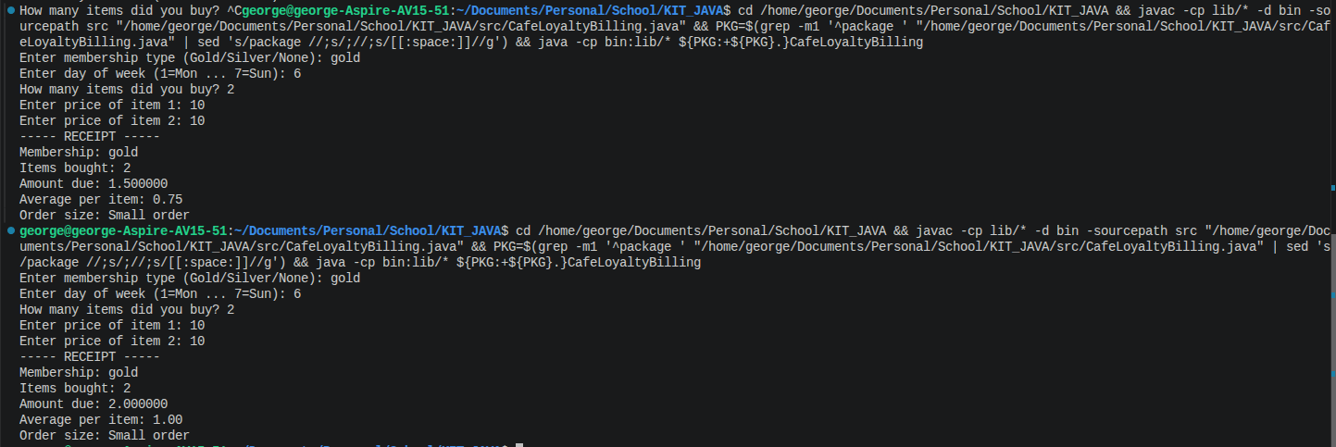
Forgetting break won’t disrupt the program but surCharge = 1.50 never applied.
- Formatting
. Line 67 printf format for total is wrong, inside the code it uses %d and it’s a wrong format for double data type. The fix is to change from %d to %f
- Missing validation
. line 15 it asks the user to type in “Gold” or “Silver” or “None” but it never checks if the user type anything else. The fix is to trap user in a while loop if they enter something beside “Gold” or “Silver” or “None”
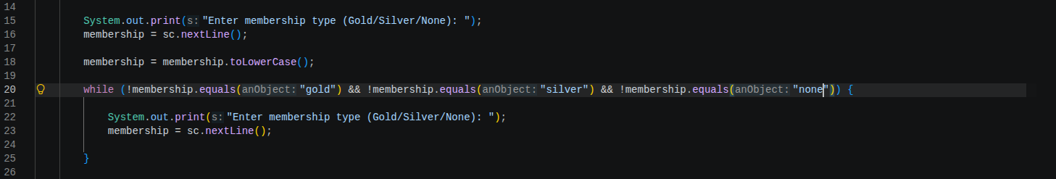

. line 27 it asks the user to type from 1 - 7 but never check what if the user type in <1 or >7. The fix is to trap users in a while loop if they enter a number that is <1 or > 7.
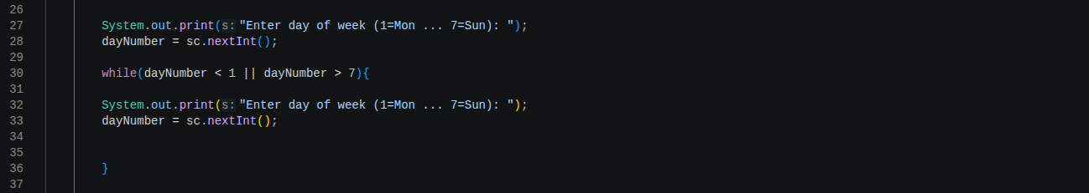

. line 38 never it ask the user how many items they bought, but it never check what if user enter negative number or 0 because at line 79 it do a division average = total / numItems which mean that number of items can’t be negative as it’s non realistic and it can’t be equal to 0 as it would give a division error. The fix is to trap the user in a while loop if they enter a number <= 0
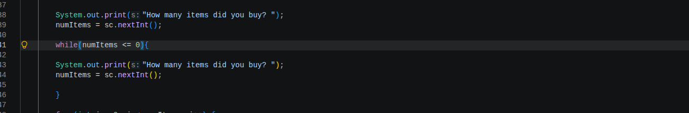
. line 48 in for loop, it never checks the user if they enter a negative price. The fix is to trap the user inside a while loop until they enter a valid number.
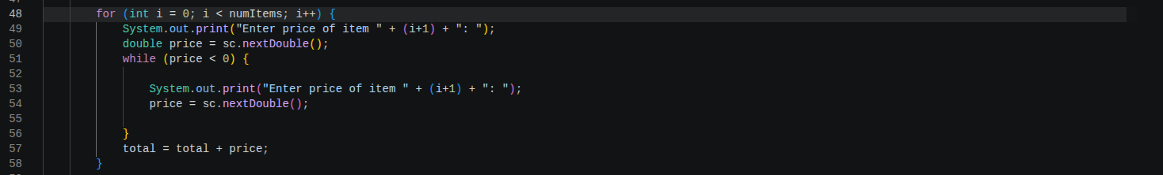

Final result of the whole flow:
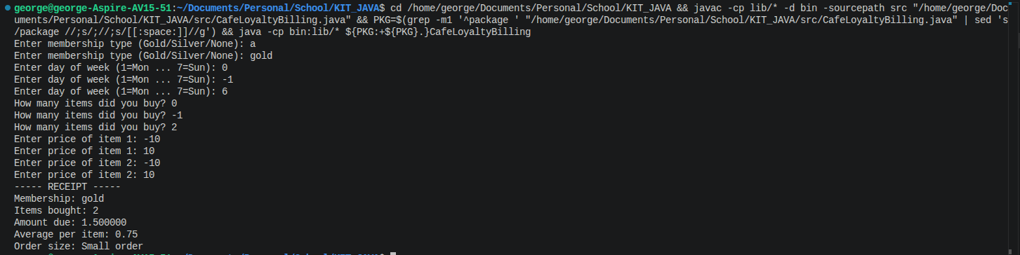

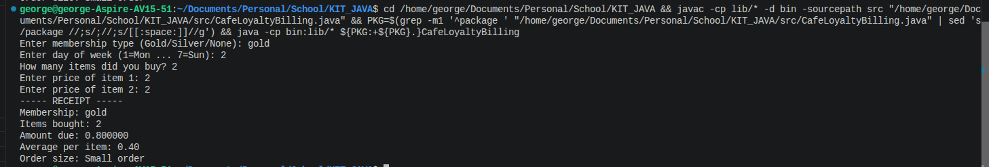
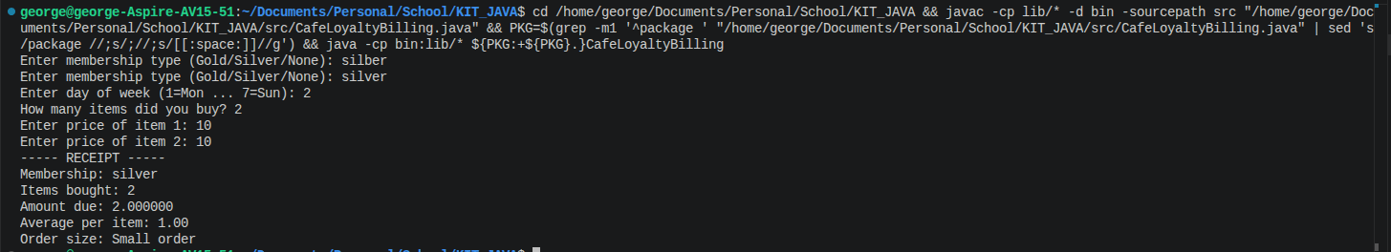

The code runs as expected, whenever the user types wrong membership, date, amount, price the user will simply be stuck inside a while loop until the user types the correct validation.

No, AI being used in this.

